Denae Luna

12 Sep 2021

Module 6

Deliverables:

1. **Google Fonts**
   1. Urbanist 200, 500 for headers, navigation, footer
   2. Montserrat light for body text and subtitles
2. **Color Pallette**

**Other Style Guide Notes:**

* Header will contain block of color at top
* Navigation will be across top horizontally. Navigation text is in all caps. Horizontal line across navigation
* Body will contain 2 divs. One left column less wide with consistent content. One right with relevant page content. Horizontal line at top and bottom of body.
* Footer will be off-color from background and contain links to home
* Images in the body will be in-line with text and vary from left to right of text. They will also all contain subtitles that are grouped with the image.
* Hyperlinks will be underlined to clearly show link
* Subtitles will be italicized.
* Unordered list will use standard bullet. Ordered list will be standard numbers.
* Simpler is better.

1. **Protoypes:**

1. **Interview Questions:**
   1. If your life was a book and you could skip to the last chapter and read it, would you? Why or why not?
   2. What characteristics do you believe define a good person?
   3. Why did you choose to do what you do?
   4. Do you believe in second chances?
   5. How did you meet your spouse?
   6. When you have free time to yourself, how do you spend it?
   7. What do you think the secret of life is?
   8. What is your next biggest goal?
   9. What do you want your legacy to be?
   10. What is the most fulfilling thing you do?
2. **Inspiration Document:** will complete once done with interview
3. **Bio:** will complete once done with interview
4. **Photos:**

Photo of person

Photos for Hobbies Page

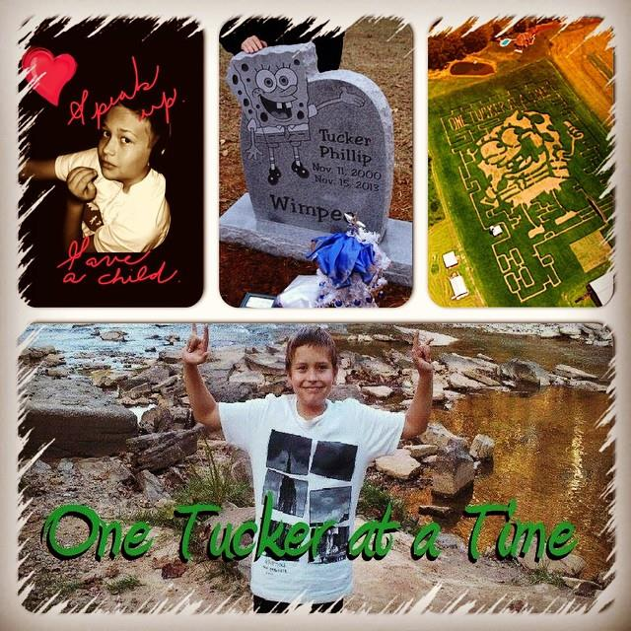

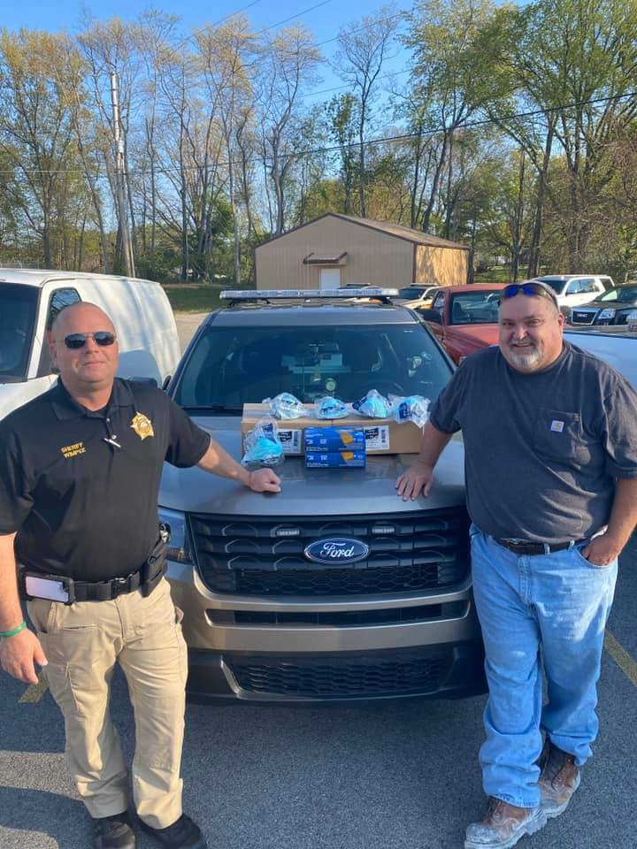

Photos for Home Page





